**// JAVA OOPS ASSIGNMENTS – 1 //**

**QUESTION 1 - >Create a class name ‘Student’ with string variable ‘name’ and integer variable ‘roll_no’. Assign the value of roll_no as ‘2’ and that of name as “Mohit” by creating an object of the class Student.**

**ANS -** 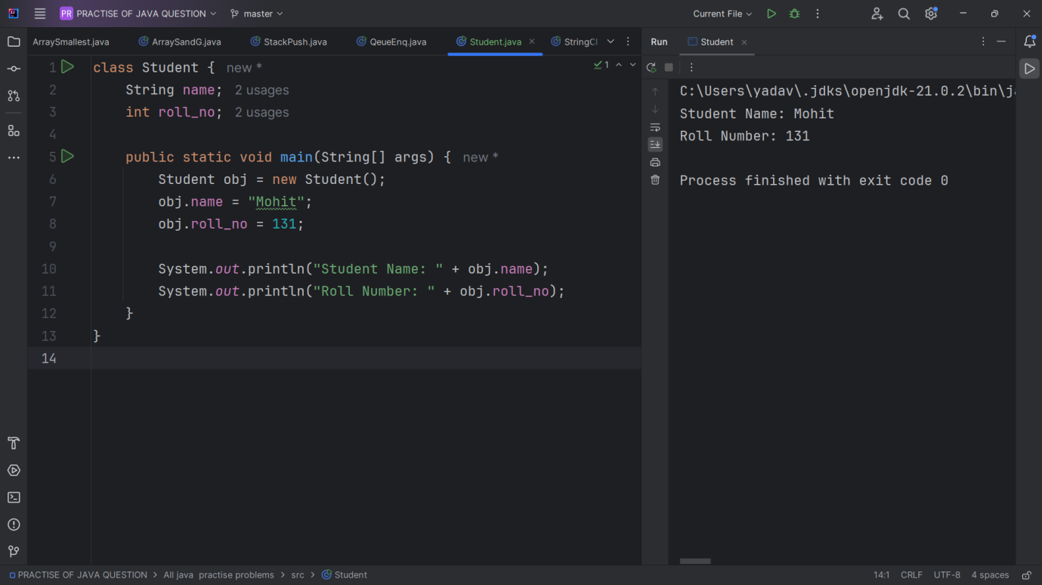

**QUESTION 2 -> Assign and print the roll number, phone number and address of two students having name “Mohit” and “Sanjay” respectively by creating two objects of class ‘Student1’.**

**ANS->** class Student1 {  
 String name;  
 int roll_no;  
 String phone_no;  
 String address;  
  
 public static void main(String[] args) {  
 Student1 student1 = new Student1();  
 student1.name = "Mohit";  
 student1.roll_no = 101;  
 student1.phone_no = "9876543210";  
 student1.address = "Delhi";  
  
 Student1 student2 = new Student1();  
 student2.name = "Sanjay";  
 student2.roll_no = 102;  
 student2.phone_no = "8765432109";  
 student2.address = "Mumbai";  
  
 System.*out*.println("Name: " + student1.name);  
 System.*out*.println("Roll Number: " + student1.roll_no);  
 System.*out*.println("Phone Number: " + student1.phone_no);  
 System.*out*.println("Address: " + student1.address);  
  
 System.*out*.println();  
  
 System.*out*.println("Name: " + student2.name);  
 System.*out*.println("Roll Number: " + student2.roll_no);  
 System.*out*.println("Phone Number: " + student2.phone_no);  
 System.*out*.println("Address: " + student2.address);  
 }  
}

**OUTPUT->**

**Name: Mohit**

**Roll Number: 101**

**Phone Number: 9876543210**

**Address: Delhi**

**Name: Sanjay**

**Roll Number: 102**

**Phone Number: 8765432109**

**Address: Mumbai**

**Process finished with exit code 0**

**QUESTION 3 ->Write a program to print the area and perimeter of a triangle having sides of 3,4 and 5 units by creating a class named ‘Triangle’ without any parameter in its constructor.**

**ANS ->** class Triangle {  
 int a, b, c;  
 double area, perimeter;  
  
 Triangle() {  
 a = 3;  
 b = 4;  
 c = 5;  
 perimeter = a + b + c;  
 double s = perimeter / 2;  
 area = Math.*sqrt*(s * (s - a) * (s - b) * (s - c));  
 }  
  
 public static void main(String[] args) {  
 Triangle obj = new Triangle();  
  
 System.*out*.println("Perimeter: " + obj.perimeter);  
 System.*out*.println("Area: " + obj.area);  
 }  
}

**OUTPUT :** **Perimeter: 12.0**

**Area: 6.0**

**QUESTION 4 -> Write a program to print the area and perimeter of a triangle having sides of 3, r and 5 unite by creating a class named ‘Triangle’ with constructors having the three sides as its parameters.**

class Triangle1 {  
 double a, b, c;  
  
 Triangle1(double a, double b, double c) {  
 this.a = a;  
 this.b = b;  
 this.c = c;  
 }  
  
 double getPerimeter() {  
 return a + b + c;  
 }  
  
 double getArea() {  
 double s = getPerimeter() / 2;  
 return Math.*sqrt*(s * (s - a) * (s - b) * (s - c));  
 }  
}  
  
public class Main {  
 public static void main(String[] args) {  
 Triangle1 t = new Triangle1(3, 4, 5);  
 System.*out*.println("Perimeter: " + t.getPerimeter());  
 System.*out*.println("Area: " + t.getArea());  
 }  
}

**OUTPUT->**

**Perimeter: 12.0**

**Area: 6.0**

**QUESTION 5 -> Write a program to print the area of two rectangles having sides(4,5) and (5,8) respectively by creating a class named ‘Rectangle’ with a method named ‘Area’ which returns the area and length and breadth passed as parameters to its constructor.**

class Rect {  
 double length, breadth;  
  
 Rect(double length, double breadth) {  
 this.length = length;  
 this.breadth = breadth;  
 }  
  
 double getArea() {  
 return length * breadth;  
 }  
}  
  
public class Main1 {  
 public static void main(String[] args) {  
 Rect r1 = new Rect(4, 5);  
 Rect r2 = new Rect(5, 8);  
 System.*out*.println("Area of first rectangle: " + r1.getArea());  
 System.*out*.println("Area of second rectangle: " + r2.getArea());  
 }  
}

**OUTPUT ->**

**Area of first rectangle: 20.0**

**Area of second rectangle: 40.0**

**QUESTION -> 6. Write a program to print the area of a rectangle by creating a class**

**named ‘Area’ having two methods. First method named as ‘setDim’ takes**

**length and breadth of rectangle as parameters and the second method**

**named as’getArea’ returns the area of the rectangle. Length and breadth**

**of rectangle are entered through keyboard.**

import java.util.Scanner;  
  
class Area {  
 private double length, breadth;  
  
 void setDim(double length, double breadth) {  
 this.length = length;  
 this.breadth = breadth;  
 }  
  
 double getArea() {  
 return length * breadth;  
 }  
}  
  
public class RectangleArea {  
 public static void main(String[] args) {  
 Scanner scanner = new Scanner(System.*in*);  
 Area rectangle = new Area();  
 System.*out*.print("Enter length: ");  
 double length = scanner.nextDouble();  
 System.*out*.print("Enter breadth: ");  
 double breadth = scanner.nextDouble();  
 rectangle.setDim(length, breadth);  
 System.*out*.println("Area of Rectangle: " + rectangle.getArea());  
 scanner.close();  
 }  
}

**OUTPUT ->**

**Enter length: 5**

**Enter breadth: 6**

**Area of Rectangle: 30.0**

**QUESTION -> 7. Write a program to print the area of a rectangle by creating a class**

**named ‘Area’ taking the values of its length and breadth as parameters of**

**its constructor and having a method named**

**‘return Area’ which returns**

**the area of the rectangle. Length and breadth of rectangle are entered**

**through keyboard.**

import java.util.Scanner;  
  
class Area1 {  
 private double length;  
 private double breadth;  
  
 Area1(double length, double breadth) {  
 this.length = length;  
 this.breadth = breadth;  
 }  
  
 double returnArea() {  
 return length * breadth;  
 }  
}  
  
public class Main3 {  
 public static void main(String[] args) {  
 Scanner scanner = new Scanner(System.*in*);  
 double length = scanner.nextDouble();  
 double breadth = scanner.nextDouble();  
 Area1 rectangle = new Area1(length, breadth);  
 System.*out*.println(rectangle.returnArea());  
 scanner.close();  
 }  
}

OUTPUT ->

10

20

200.0

QUESTION -> 8. Print the average of three numbers entered by user by creating a class

named ‘Average’ having a method to calculate and print the average.

import java.util.Scanner;  
  
class Average {  
 void calculateAndPrintAverage(double num1, double num2, double num3) {  
 double average = (num1 + num2 + num3) / 3;  
 System.*out*.println("Average: " + average);  
 }  
}  
  
public class Main5 {  
 public static void main(String[] args) {  
 Scanner scanner = new Scanner(System.*in*);  
 System.*out*.print("Enter three numbers: ");  
 double num1 = scanner.nextDouble();  
 double num2 = scanner.nextDouble();  
 double num3 = scanner.nextDouble();  
 scanner.close();  
 Average avg = new Average();  
 avg.calculateAndPrintAverage(num1, num2, num3);  
 }  
}

OUTPUT->

Enter three numbers: 5

4

3

Average: 4.0

QUESTION -> 9. Print the sum, difference and product of two complex numbers by

creating a class named Complex with separate methods for each

operation whose real and imaginary parts are entered by user.

import java.util.Scanner;  
  
class Complex {  
 private double real, imag;  
  
 Complex(double real, double imag) {  
 this.real = real;  
 this.imag = imag;  
 }  
  
 Complex add(Complex other) {  
 return new Complex(this.real + other.real, this.imag + other.imag);  
 }  
  
 Complex subtract(Complex other) {  
 return new Complex(this.real - other.real, this.imag - other.imag);  
 }  
  
 Complex multiply(Complex other) {  
 double realPart = this.real * other.real - this.imag * other.imag;  
 double imagPart = this.real * other.imag + this.imag * other.real;  
 return new Complex(realPart, imagPart);  
 }  
  
 void display() {  
 System.*out*.println(real + (imag >= 0 ? " + " : " ") + imag + "i");  
 }  
}  
  
public class ComplexOperations {  
 public static void main(String[] args) {  
 Scanner scanner = new Scanner(System.*in*);  
 System.*out*.print("Enter real and imaginary part of first complex number: ");  
 Complex num1 = new Complex(scanner.nextDouble(), scanner.nextDouble());  
 System.*out*.print("Enter real and imaginary part of second complex number: ");  
 Complex num2 = new Complex(scanner.nextDouble(), scanner.nextDouble());  
 System.*out*.print("Sum: ");  
 num1.add(num2).display();  
 System.*out*.print("Difference: ");  
 num1.subtract(num2).display();  
 System.*out*.print("Product: ");  
 num1.multiply(num2).display();  
 scanner.close();  
 }  
}

OUTPUT->

Enter real and imaginary part of first complex number: 8

9

Enter real and imaginary part of second complex number: 6

4

Sum: 14.0 + 13.0i

Difference: 2.0 + 5.0i

Product: 12.0 + 86.0i

QUESTION -> 10. Write a program that would print the information (name, year of

joining, salary, address) of three employees by creating a class named

Employee. The output should be as follows:

Name        Year of joining        Address

Ram            1994                64C- Bhopal

Praveen               2000                68D- Bhopal

Yash                1999                26B- Bhopal

class Employee {  
 String name;  
 int yearOfJoining;  
 String address;  
  
 Employee(String name, int yearOfJoining, String address) {  
 this.name = name;  
 this.yearOfJoining = yearOfJoining;  
 this.address = address;  
 }  
  
 void display() {  
 System.*out*.printf("%-10s %-20d %s\n", name, yearOfJoining, address);  
 }  
  
 public static void main(String[] args) {  
 System.*out*.printf("%-10s %-20s %s\n", "Name", "Year of joining", "Address");  
 Employee e1 = new Employee("Ram", 1994, "64C- Bhopal");  
 Employee e2 = new Employee("Praveen", 2000, "68D- Bhopal");  
 Employee e3 = new Employee("Yash", 1999, "26B- Bhopal");  
 e1.display();  
 e2.display();  
 e3.display();  
 }  
}

OUTPUT->

Name Year of joining Address

Ram 1994 64C- Bhopal

Praveen 2000 68D- Bhopal

Yash 1999 26B- Bhopal

QUESTION -> 13. Create a class called Matrix containing constructor that initializes

the number of rows and number of columns of a new Matrix object. The

Matrix class has the following information:

1 - number of rows of matrix

2 - number of columns of matrix

3 - elements of matrix in the form of 2D array

import java.util.Scanner;  
  
class Matrix {  
 int rows;  
 int cols;  
 int[][] elements;  
  
 Matrix(int rows, int cols) {  
 this.rows = rows;  
 this.cols = cols;  
 this.elements = new int[rows][cols];  
 }  
  
 void inputElements() {  
 Scanner scanner = new Scanner(System.*in*);  
 for (int i = 0; i < rows; i++) {  
 for (int j = 0; j < cols; j++) {  
 elements[i][j] = scanner.nextInt();  
 }  
 }  
 }  
  
 void displayMatrix() {  
 for (int i = 0; i < rows; i++) {  
 for (int j = 0; j < cols; j++) {  
 System.*out*.print(elements[i][j] + " ");  
 }  
 System.*out*.println();  
 }  
 }  
  
 public static void main(String[] args) {  
 Scanner scanner = new Scanner(System.*in*);  
 int rows = scanner.nextInt();  
 int cols = scanner.nextInt();  
 Matrix matrix = new Matrix(rows, cols);  
 matrix.inputElements();  
 matrix.displayMatrix();  
 }  
}

OUTPUT ->

3 3

4 5 6

7 8 9

1 2 3

4 5 6

7 8 9

1 2 3

QUESTION -> 15.  Create a class called Student that stores its name, class, section, and

marks in four subjects. Write functions to accept, display and get/set of

the data. Also write methods that return its total and percentage. Test the

above code by creating an implementation program.

import java.util.Scanner;  
  
class Student3 {  
 String name;  
 String studentClass;  
 char section;  
 int[] marks = new int[4];  
  
 Student3(String name, String studentClass, char section, int[] marks) {  
 this.name = name;  
 this.studentClass = studentClass;  
 this.section = section;  
 System.*arraycopy*(marks, 0, this.marks, 0, 4);  
 }  
  
 void setName(String name) {  
 this.name = name;  
 }  
  
 String getName() {  
 return name;  
 }  
  
 void setStudentClass(String studentClass) {  
 this.studentClass = studentClass;  
 }  
  
 String getStudentClass() {  
 return studentClass;  
 }  
  
 void setSection(char section) {  
 this.section = section;  
 }  
  
 char getSection() {  
 return section;  
 }  
  
 void setMarks(int[] marks) {  
 System.*arraycopy*(marks, 0, this.marks, 0, 4);  
 }  
  
 int[] getMarks() {  
 return marks;  
 }  
  
 int getTotalMarks() {  
 int total = 0;  
 for (int mark : marks) {  
 total += mark;  
 }  
 return total;  
 }  
  
 double getPercentage() {  
 return getTotalMarks() / 4.0;  
 }  
  
 void displayStudent() {  
 System.*out*.println("Name: " + name);  
 System.*out*.println("Class: " + studentClass);  
 System.*out*.println("Section: " + section);  
 System.*out*.println("Total Marks: " + getTotalMarks());  
 System.*out*.printf("Percentage: %.2f%%\n", getPercentage());  
 }  
  
 public static void main(String[] args) {  
 Scanner scanner = new Scanner(System.*in*);  
 System.*out*.print("Enter name: ");  
 String name = scanner.nextLine();  
 System.*out*.print("Enter class: ");  
 String studentClass = scanner.nextLine();  
 System.*out*.print("Enter section: ");  
 char section = scanner.next().charAt(0);  
 int[] marks = new int[4];  
 System.*out*.print("Enter marks in 4 subjects: ");  
 for (int i = 0; i < 4; i++) {  
 marks[i] = scanner.nextInt();  
 }  
 Student3 student = new Student3(name, studentClass, section, marks);  
 student.displayStudent();  
 }  
}

OUTPUT ->

Enter name: MOHIT YADAV

Enter class: 12

Enter section: B

Enter marks in 4 subjects: 49

69

78

86

Name: MOHIT YADAV

Class: 12

Section: B

Total Marks: 282

Percentage: 70.50%

QUESTION -> 16. Create a class that counts the number of its objects created. If the

object counter is equal to 5, it should display a message “Too Less…”

on the screen at the time of object creation. Like when its is

equal to 5 then “Will Do…” and if its more than 5 then it should display

“Exceeding the Limits…” Write suitable constructors and methods. Also

write methods that returns the number of objects created.

class ObjectCounter {  
 private static int *count* = 0;  
  
 ObjectCounter() {  
 *count*++;  
 if (*count* == 5) {  
 System.*out*.println("Will Do...");  
 } else if (*count* < 5) {  
 System.*out*.println("Too Less...");  
 } else {  
 System.*out*.println("Exceeding the Limits...");  
 }  
 }  
  
 static int getObjectCount() {  
 return *count*;  
 }  
  
 public static void main(String[] args) {  
 ObjectCounter obj1 = new ObjectCounter();  
 ObjectCounter obj2 = new ObjectCounter();  
 ObjectCounter obj3 = new ObjectCounter();  
 ObjectCounter obj4 = new ObjectCounter();  
 ObjectCounter obj5 = new ObjectCounter();  
 ObjectCounter obj6 = new ObjectCounter();  
 }  
}

OUTPUT ->

Too Less...

Too Less...

Too Less...

Too Less...

Will Do...

Exceeding the Limits...

1.The Circle Class (An Introduction to Classes and Instances)

A class called circle is designed as shown in the following class diagram. It contains:

● Two private instance variables: radius (of the type double) and color (of the type String),

with default value of 1.0 and &quot;red&quot;, respectively.

● Two overloaded constructors - a default constructor with no argument, and a

constructor which takes a double argument for radius.

● Two public methods: getRadius() and getArea(), which return the radius and area of this

instance, respectively.

public class Circle {  
 private double radius = 1.0;  
 private String color = "red";  
  
 public Circle() {  
 }  
  
 public Circle(double radius) {  
 this.radius = radius;  
 }  
  
 public double getRadius() {  
 return radius;  
 }  
  
 public double getArea() {  
 return Math.*PI* * radius * radius;  
 }  
}

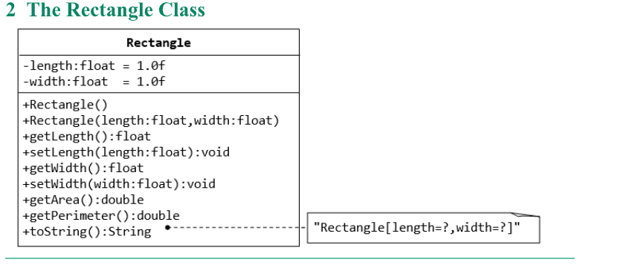

public class Rectangle2 {  
 private float length = 1.0f;  
 private float width = 1.0f;  
  
 public Rectangle2() {  
 }  
  
 public Rectangle2(float length, float width) {  
 this.length = length;  
 this.width = width;  
 }  
  
 public float getLength() {  
 return length;  
 }  
  
 public void setLength(float length) {  
 this.length = length;  
 }  
  
 public float getWidth() {  
 return width;  
 }  
  
 public void setWidth(float width) {  
 this.width = width;  
 }  
  
 public double getArea() {  
 return length * width;  
 }  
  
 public double getPerimeter() {  
 return 2 * (length + width);  
 }  
  
 @Override  
 public String toString() {  
 return "Rectangle2[length=" + length + ", width=" + width + "]";  
 }  
  
 public static void main(String[] args) {  
 Rectangle2 rect1 = new Rectangle2();  
 Rectangle2 rect2 = new Rectangle2(4.5f, 3.2f);  
  
 System.*out*.println("Rectangle2 1 - " + rect1.toString());  
 System.*out*.println("Rectangle2 2 - " + rect2.toString());  
 System.*out*.println("Rectangle2 2 Area: " + rect2.getArea());  
 System.*out*.println("Rectangle2 2 Perimeter: " + rect2.getPerimeter());  
 }  
}

OUTPUT ->

Rectangle2 1 - Rectangle2[length=1.0, width=1.0]

Rectangle2 2 - Rectangle2[length=4.5, width=3.2]

Rectangle2 2 Area: 14.40000057220459

Rectangle2 2 Perimeter: 15.399999618530273